**Quiz –Create following summary table**

**1.Use –Superstore_Canada.xls and format your numbers exactly like shown in screenshot below:-**

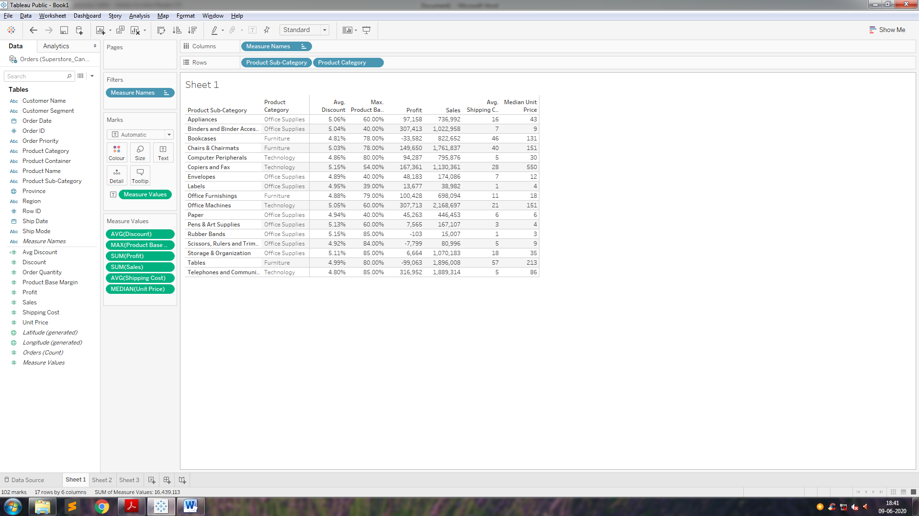

**2. Use –Superstore_Canada.xls and format your numbers exactly like shown in screenshot below :-**



**3. Import –Superstore_Canada.xls (Sheet –Orders) and answer the following questions:**

A.What is the total sales of the store?

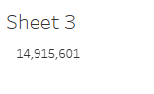

B.What is the total sales of product category = “Furniture”?

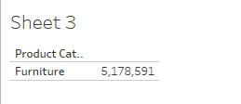

C.What is the total sales of product category = “Furniture” sold to Customer Segment = “Corporate”?

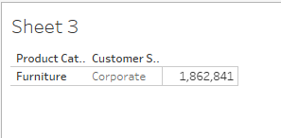

D.Set the default number format of Discount to percentage with 2 decimal places.

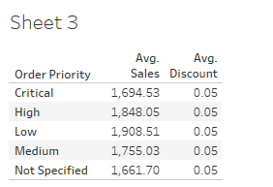

E. Find average discount on each order priority. Which order priority has highest average discount?

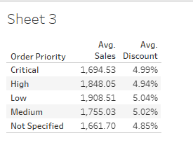

**4. Import –Superstore_Canada.csv and answer the following questions:**

A. For Product Container = “Large Box” which Ship Mode has lowest average shipping cost?

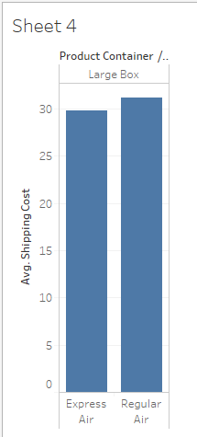 Ans:- Express Air

B. For Product Container = “Medium Box” which Ship Mode has lowest average shipping cost?

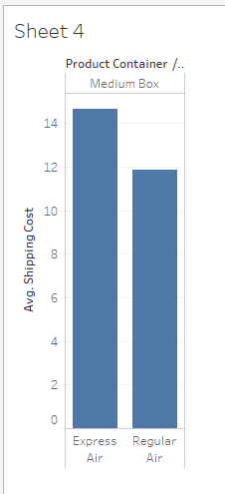Ans:- Regular Air

C. Which Ship Mode uses only “Jumbo” sized Product Containers?

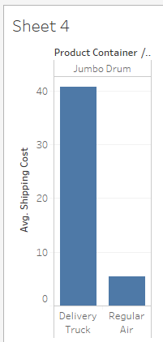

Ans : - Delivery Truck

D. Which Ship Mode doesn’t entertain “Jumbo” sized Product Containers?

Ans : - Express Air